SCHOOL OF TECHNOLOGY, DESIGN AND COMPUTER APPLICATION COLLEGE OF TECHNOLOGY

ADITYA SILVER OAK INSTITUTE OF TECHNOLOGY

DEPARTMENT OF COMPUTER ENGINEERING

A Report on

Smart Internship & Job Finder Portal for Students

Under Subject of
PROBLEM BASED LEARNING – II
(Subject Code: 1010003391) Semester – VI

Submitted by
Patel Smit Shashankbhai 2402030430089 Shah Jash Priteshkumar 2402030430010 Shah Prem Jigneshkumar 2402030430064 Shah Jeet Mehubhai 2402030430024 Shukla Khush Dipeshbhai 2402030430106



Silver Oak University

CERTIFICATE

This is to certify that the project entitled "Smart Internship & Job Finder Portal for Students" has been carried out by Patel Smit Shashankbhai (2402030430089), Shah Jash Priteshkumar (2402030430010), Shah Prem Jigneshkumar (2402030430064), Shah Jeet Mehubhai (2402030430024), and Shukla Khush Dipeshbhai (2402030430106), under the guidance of Prof. Juhi Gor, in partial fulfillment of the requirements for the subject Problem Based Learning – I (1010003391) of Bachelor of Engineering in Computer Engineering, 5th Semester, Silver Oak University, Ahmedabad, during the academic year 2025–2026.

Prof. Ms.Juhi Gor Prof. Mr.Mayuresh Kulkarni
Internal Guide Head of the Department
Dept. of Computer Engineering Dept. of Computer Engineering Silver Oak University Silver Oak University

ACKNOWLEDGEMENT

We are heartily thankful to our supervisor, Prof. Juhi Gor, whose encouragement, supervision, and support from the preliminary to the concluding level enabled us to develop an understanding of the subject. We offer our regards and blessings to all of those who supported us in any respect during the completion of the project and to our college for providing resources and materials.

We would like to extend our gratitude to Prof. Mayuresh Kulkarni, Head of the Computer Engineering Department, Aditya Silver Oak Institute of Technology, Ahmedabad, for his continuous encouragement and motivation throughout this project.

Last but not the least, we would like to mention that we are greatly indebted to every individual who has been associated with our project at any stage but whose name does not find a place in this acknowledgement.

Yours Sincerely,

Patel Smit Shashankbhai – 2402030430089 Shah Jash Priteshkumar – 2402030430010 Shah Prem Jigneshkumar – 2402030430064 Shah Jeet Mehubhai – 2402030430024 Shukla Khush Dipeshbhai – 2402030430106

ABSTRACT

The Smart Internship & Job Finder Portal for Students is a web-based platform designed to bridge the gap between students seeking internships or job opportunities and companies offering them. The portal aims to simplify and automate the recruitment process through intelligent matching algorithms and a user-friendly interface. Students can create profiles, upload resumes, and specify their skills, academic background, and career interests. Recruiters can post openings, define eligibility criteria, and search for suitable candidates efficiently. The system incorporates smart recommendation features that suggest the most relevant internships or jobs to students based on their profiles and preferences using data-driven filtering techniques. Additionally, the portal includes features such as application tracking, interview scheduling, notification alerts, and company reviews to enhance user engagement and transparency. By leveraging modern technologies such as HTML5, CSS3, JavaScript, Python (Django/Flask), and MySQL 8.0, the portal provides a reliable and scalable solution for career development and talent acquisition. Ultimately, this project empowers students to discover suitable opportunities easily while helping employers identify skilled and motivated candidates effectively.

LIST OF FIGURES

Figure No. | Figure Name | Page No.
3.5 | ER Diagram – SkillBridge System | 11
3.5.1 | Sign In Page | 11
3.5.2 | Home Page | 12
3.5.3 | Admin Dashboard | 13
3.5.4 | Student /user can see notifiaction | 13
3.5.5 | Student internship View | 13
3.6.1 | Level 0 Context Data Flow Diagram (DFD) | 15
3.6.2 | Level 1 Data Flow Diagram (DFD) | 15
5.1 | Project Timeline Distribution Pie Chart | 19

LIST OF TABLES

Table No. | Table Name | Page No.
2.2.1 | Hardware Requirements | 10
2.2.2 | Software Requirements | 11
5.1 | Timeline Distribution Table | 30

TABLE OF CONTENTS

Acknowledgement | iii
Abstract | iv
List of Figures | v
List of Tables | vi
Chapter 1: Introduction | 1
1.1 Project Summary | 1
1.2 Purpose | 2
1.3 Scope | 3
1.4 Technical and Literature Review | 4
Chapter 2: System Requirement Study | 7
2.1 User Characteristics | 7
2.2 Hardware and Software Requirements | 10
Chapter 3: System Analysis | 13
3.1 Study of Current System | 13
3.2 Problems in Existing System | 14
3.3 Requirement of New System | 15
3.4 Feasibility Study | 18
3.5 Main Modules of New System (UML) | 19
3.6 Data Flow Diagram (DFD) | 23
Chapter 4: Limitations and Future Enhancements | 25
Chapter 5: Timeline Chart | 29
Chapter 6: Conclusion | 31

Chapter 1: Introduction

Project Summary
The Smart Internship & Job Finder Portal for Students, branded as SkillBridge, is a web-based application developed to assist students in finding suitable internship and job opportunities efficiently. The primary objective of this project is to create a smart, interactive, and centralized platform that connects students with employers, simplifies the recruitment process, and reduces the communication gap between both parties.
The system enables students to register on the platform, build comprehensive profiles, upload their resumes, and apply for various internship or job openings that match their skills, qualifications, and career interests. Simultaneously, companies and recruiters can post available positions with detailed eligibility criteria and review applications submitted by potential candidates in an organized and efficient manner.
A defining feature of this project is its smart recommendation system, which automatically identifies and suggests the most relevant opportunities to each student based on their individual profiles and preferences through filtering and matching algorithms. The portal also incorporates functionalities such as secure login authentication, role-based access control, admin management, application status tracking, notification alerts, and a comprehensive dashboard for different user roles.

Purpose
The purpose of this project is to create a smart, efficient, and user-friendly platform that helps students easily find internships and job opportunities that match their skills, interests, and qualifications. A large number of students face significant difficulties in identifying the right career opportunities and establishing direct connections with companies. This portal aims to bridge that gap by providing a single unified platform where students and recruiters can interact seamlessly and effectively.
The system simplifies the entire hiring process, from searching and applying to tracking application status and receiving real-time updates. It enables companies to reach qualified candidates quickly and allows students to explore verified openings without depending on third-party intermediaries or scattered online sources. By centralizing information and automating routine tasks, the portal saves significant time and effort for all parties involved in the career development process.

Scope
The Smart Internship & Job Finder Portal for Students addresses a critical need in the academic and professional ecosystem by targeting the specific challenges faced by college students while searching for career opportunities. The portal provides an intelligent, user-friendly, and centralized platform where students can create detailed profiles, upload resumes, and apply for positions relevant to their academic background and skill set. The scope of the system encompasses three primary user types: students, employers, and administrators, each interacting through a dedicated role-based interface.
The system allows companies to post internship and job openings, review student applications, and communicate with potential candidates directly through the portal. Advanced search and filtering features help students find opportunities based on criteria such as location, field of interest, experience level, required skills, and preferred duration. The scope also includes an AI-assisted recommendation engine, application status tracking, interview scheduling coordination, and a real-time notification system. The system is designed to be scalable and extendable, allowing future additions such as a mobile application, live chat, and automated resume parsing using Natural Language Processing.

Technical and Literature Review
Several online platforms such as LinkedIn, Internshala, and Handshake already exist for job and internship searching. These platforms allow users to upload resumes, apply for jobs, and connect with employers. However, they are primarily designed for a broad, general audience and do not cater specifically to the unique needs of college students, particularly those in the early stages of their professional careers.
Recent research and development in the career platform domain has demonstrated the significant value of Artificial Intelligence and Machine Learning in job recommendation systems. These technologies analyze a student's profile and suggest the most suitable opportunities based on skills, educational background, and career interests. Systems employing collaborative filtering, content-based filtering, and hybrid approaches have shown measurable improvements in recommendation relevance compared to traditional keyword-based search mechanisms.
Some advanced systems also utilize Natural Language Processing techniques to automatically read and interpret uploaded resumes, extracting key information such as skills, educational qualifications, and relevant experience without requiring

manual data entry. The SkillBridge system draws inspiration from these approaches while keeping implementation feasible within the scope of an academic semester project, using a simplified filtering and scoring algorithm built on top of a relational database.

Technical Review
The portal is designed as a three-tier web-based application. The presentation layer is handled by HTML5, CSS3, JavaScript, and Bootstrap 5.3, ensuring a responsive and accessible user interface across devices. The application layer is built using Python with either the Django 4.x or Flask 3.x framework, which handles server-side logic, routing, session management, and data processing. The data layer uses MySQL 8.0 as the relational database management system to store and manage user profiles, job postings, and application records. The system connects three primary user roles, namely Students, Employers, and Administrators, each with distinct levels of access and functionality defined through role-based access control.
The main features and modules of the system include a User Registration and Login module with secure authentication, a Profile Management module allowing students to maintain personal details and skill sets, a Resume Upload and Parsing module, an Internship and Job Posting module for employers, a Smart Recommendation System based on profile-job matching algorithms, and a Search and Filter Option enabling students to query opportunities by location, company, or required skill. An Application Tracking module notifies students of status changes, while the Admin Dashboard provides system-wide oversight including content moderation and user management.

Chapter 2: System Requirement Study

User Characteristics

Student (Primary User)
Students constitute the primary user group of the SkillBridge portal. They are typically college or university students who possess basic computer and internet literacy and are actively seeking internships, part-time jobs, or fresher-level employment positions. Students interact with the system through standard web browsers on desktop or mobile devices. Upon registration and login, a student can create and maintain a personal profile that includes educational details, skills, and career interests. The system provides each student with personalized recommendations, application tracking with statuses such as Applied, Shortlisted, Rejected, or Hired, and real-time notifications about new opportunities or updates to existing applications.

Employer (Company / Recruiter)
Employers represent the second major user group on the platform. They include HR professionals, company representatives, startup founders, and individual recruiters who wish to post internship or entry-level job openings and connect with qualified student candidates. Employers are assumed to have domain knowledge of job requirements and a preference for a streamlined hiring workflow. Upon registration and admin approval, an employer can create and manage a company profile, post new job or internship listings with detailed information, view and shortlist incoming applications from students, update application statuses, and communicate with selected candidates through the portal's messaging functionality.

Admin (System Administrator)
The administrator is the primary controller of the entire SkillBridge system. This role is typically assumed by a technically competent system operator who has full access to all modules and data within the platform. The admin is responsible for approving or rejecting new employer registrations to prevent unauthorized or fraudulent listings, monitoring and managing all student and employer accounts, reviewing and removing inappropriate or spam job postings, handling complaints, generating system-wide reports and usage statistics, maintaining data security, and ensuring regular data backups. The admin role exists to maintain the integrity, reliability, and trust of the platform for all other users.

Hardware and Software Requirements

Hardware Requirements

Component | Specification | Description
Processor (CPU) | Intel Core i3 or equivalent | For running the web application and development environment
RAM | Minimum 4 GB | For basic performance and multitasking during development
Hard Disk | Minimum 250 GB | To store source code, database, and uploaded files
Monitor | 15-inch or larger | For viewing web pages and application interface
Keyboard & Mouse | Standard input devices | For easy navigation and data entry
Internet Connection | Minimum 2 Mbps | Required for accessing and testing the web portal
Table 2.2.1: Hardware Requirements

Software Requirements

Category | Software / Tool | Version | Purpose
OS | Windows 10/11, Ubuntu 22.04 | — | Running and hosting the application
Frontend | HTML5, CSS3, JS,  Bootstrap | Bootstrap 5.3 | User interface design and development
Backend | Python (Django or Flask) | Django 4.x / Flask 3.x | Server-side logic and processing
Database | MySQL | MySQL 8.0 | Storing user, job, and application data
Testing | Postman, Chrome, Firefox | Latest | Testing APIs and the web portal
Hosting | Firebase / AWS / Vercel | Latest | Deploying the website online

Version Control | Git / GitHub | Git 2.x | Source code management and collaboration
IDE | VS Code / PyCharm | Latest | Development and debugging environment
Table 2.2.2: Software Requirements

Chapter 3: System Analysis

Study of Current System
Currently, students face considerable challenges when searching for internships and job opportunities. The existing methods available to students are either largely manual or semi-digital, including reliance on social media groups, college notice boards, email notifications from placement cells, or registration on multiple job portals such as LinkedIn, Naukri, and Internshala. Students often spend significant time browsing through multiple websites, repeatedly filling out application forms, and uploading their resumes on each individual platform. This scattered, fragmented process is time-consuming, inefficient, and particularly overwhelming for students who are new to job searching.
On the employer side, companies also face difficulties managing applications efficiently. Job postings are spread across various platforms, making it challenging for recruiters to track applicants or shortlist candidates from a single interface. There is typically no centralized system where all applications can be accessed and managed in one place. Furthermore, most existing platforms do not offer intelligent matching between student skills and job requirements, resulting in students applying for roles they are not qualified for, or missing opportunities they are well-suited for.

Problems in Existing System
The current internship and job search process faces several significant problems. The process is time-consuming and scattered: students are required to navigate multiple websites, social media groups, and college notice boards to find suitable openings. They must fill out separate application forms and upload resumes on each platform, leading to unnecessary duplication of effort and considerable frustration. This inefficiency discourages many students from applying proactively and reduces their chances of securing suitable opportunities in a timely manner.
Another major problem is the lack of personalized recommendations. Existing systems do not intelligently match a student's skills, educational background, or interests with the most suitable available opportunities. As a result, students may either miss highly relevant jobs or apply to positions for which they are not fully qualified. Communication gaps represent yet another challenge, as there is no direct or efficient communication channel between students and employers regarding application progress. Additionally, students often face difficulty tracking their

application status, since many platforms do not provide clear or timely updates.

Requirement of New System

Functional Requirements Student Functional Requirements
Students must be able to register on the portal and log in securely using their
credentials. Each student can create and update a detailed personal profile that includes personal information, educational background, and skill sets. The system must allow students to upload resumes in PDF or DOCX format, search and filter available listings by location, required skills, duration, or company name, and receive smart personalized recommendations based on their profile. Students must be able to apply for positions directly through the portal and track the real-time status of each application. The system should send notifications and alerts about new relevant opportunities and updates to existing applications.

Employer Functional Requirements
Employers must be able to register on the portal and log in securely following admin approval. They can create and maintain a detailed company profile and post new job or internship openings with full details such as title, description, required skills, location, stipend, and duration. Employers should be able to view all incoming applications, shortlist or reject candidates based on their submitted profiles, and communicate with selected students regarding interview scheduling or further steps in the hiring process.

Admin Functional Requirements
The administrator must be able to approve or reject new employer registrations to maintain platform integrity. The admin can monitor and manage all user accounts, approve or remove inappropriate job postings, generate comprehensive system reports and usage statistics, and maintain data security through regular backups to ensure the smooth and uninterrupted operation of the system.

Non-Functional Requirements Performance Requirements
The system should load all pages within 3 to 5 seconds under normal network
conditions. It must handle multiple concurrent users simultaneously without performance degradation or crashes. All database queries and search operations should be optimized for quick response times, and the portal should support at least 500 or more active users at any given time.

Security Requirements
The system must provide secure login functionality using unique usernames and passwords. All sensitive information including passwords and personal data must be encrypted using industry-standard hashing algorithms such as bcrypt. Only authorized users with the appropriate role (Admin, Employer, or Student) should be granted access to their respective modules. The system should also include data backup and recovery mechanisms to prevent data loss due to system failures.

Usability and Reliability Requirements
The interface must be simple, user-friendly, and easy to navigate for all types of users. Students and employers should be able to complete their primary tasks without specialized technical knowledge. The system should include clear instructions, intuitive menus, and actionable buttons, and provide meaningful feedback messages to keep users informed about the outcome of their actions. The portal should be available 24 hours a day, 7 days a week, with minimal unplanned downtime, and must ensure that no duplicate or inconsistent records are stored in the database.

Scalability Requirements
The system should be architected to accommodate future growth, including an increasing number of users and the addition of new features. The underlying database schema and hosting infrastructure should support horizontal scaling as user demand increases over time.

Feasibility Study

Technical Feasibility
The system can be developed using readily available and widely documented technologies such as HTML5, CSS3, JavaScript, Python with Django or Flask, and MySQL 8.0. All required software tools and frameworks are open-source or free to use for academic purposes, eliminating the need for expensive software licenses. Deployment can be achieved using cloud services such as Firebase, AWS, or Vercel. Therefore, the project is technically feasible using existing resources available to the development team.

Economic Feasibility
The total development cost of this project is very low, given that the majority of tools and frameworks involved are free of charge. Minimal expenses may be incurred for domain registration and cloud hosting services. The portal delivers high

practical value at low cost and is entirely suitable for development within the budget of a college academic project.

Operational and Time Feasibility
The system is designed to be easy to use by students, employers, and administrators without requiring specialized technical training. It simplifies common tasks and features a clean, intuitive interface accessible even for users with basic computer knowledge. The complete development cycle including system design, coding, testing, and deployment is achievable within a few months and is well-suited to the timeline of a semester-long academic project.

Legal Feasibility
The system adheres to legal and ethical standards for data usage, storage, and privacy. All user information is stored securely in compliance with applicable data protection guidelines. All third-party libraries, frameworks, and tools used in the development are open-source and legally permitted for academic and non-commercial use.

Main Modules of New System (UML Diagram)
The Use Case Diagram below illustrates the primary interactions between the system's three actor types — Student, Senior User, Employer, and Admin — and the core functional modules of the SkillBridge portal. The diagram follows standard UML notation and reflects the role-based access control structure described in the requirements analysis. Each actor interacts with a specific subset of system use cases, while certain modules such as the Dashboard are shared across roles with different viewing privileges.

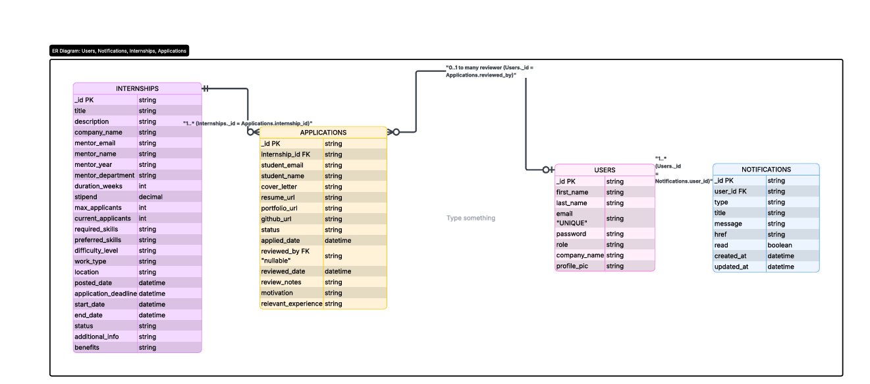

Figure 3.5: E-R diagram – SkillBridge System

Sign In Page
The Sign In page serves as the authentication gateway to the SkillBridge platform. Users are presented with a role selection dropdown that allows them to identify themselves as a Student, Employer, or Admin prior to entering their credentials. The page features a clean, minimalist design with SkillBridge branding at the top, followed by email and password input fields and a prominent Sign In button. Links for password recovery and new account registration are also provided. The interface uses a green and white colour scheme consistent with the platform's overall branding identity.

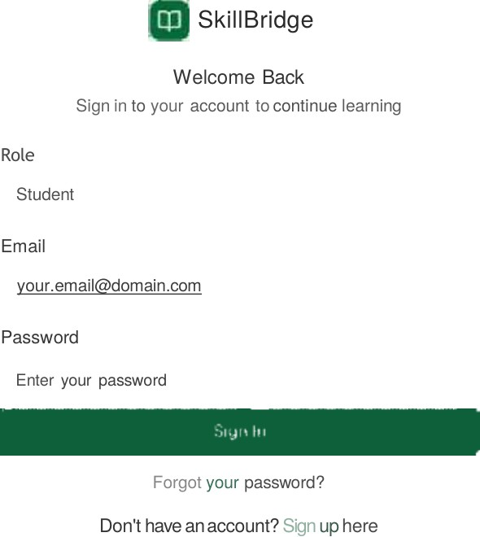

Figure 3.5.1: Sign In Page

Home Page
The Home Page serves as the public-facing landing page of the SkillBridge platform, accessible to all visitors before authentication. It prominently features the tagline "Bridge the Gap Between Learning and Experience," encapsulating the platform's core mission. The page includes navigation links to Learn, Teach, Internships, and Dashboard sections, along with Login and Sign Up call-to-action buttons. The hero section highlights that the platform is an AI-powered learning tool designed to help students connect with peers, gain real-world experience through micro-internships, and build a professional portfolio with AI-guided learning paths.
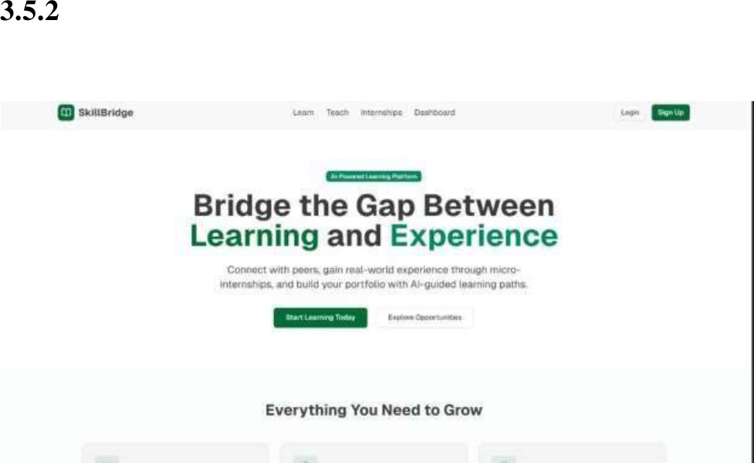

Figure 3.5.2: Home Page

Dashboard
The Dashboard provides each authenticated user with a comprehensive overview of their activity on the SkillBridge platform. For students, it displays key metrics including the number of Learning Sessions completed, Skills Taught, active Internships, and Portfolio Views, with trend indicators showing week-over-week changes. A Recent Activity panel lists the user's latest actions such as completed sessions, submitted projects, and earned skill badges. A Quick Actions panel provides direct shortcuts to common tasks including finding learning sessions, offering to teach, browsing internships, and checking messages. The dashboard design prioritizes information density while maintaining visual clarity through a card-based layout.

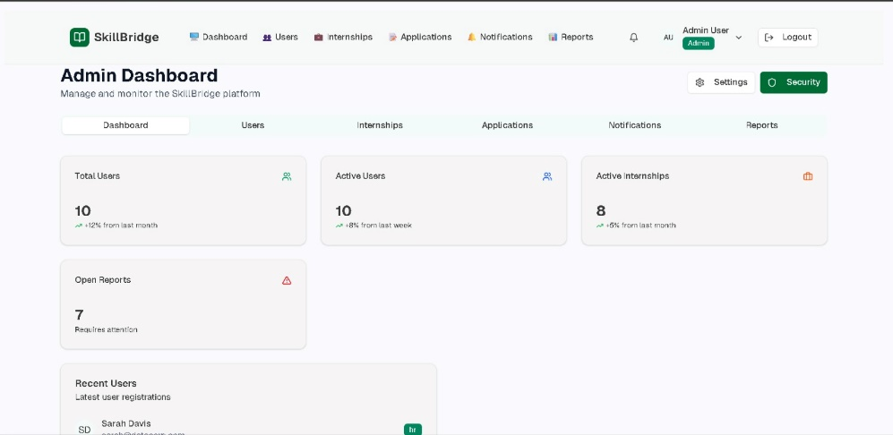

Figure 3.5.3:Admin Dashboard

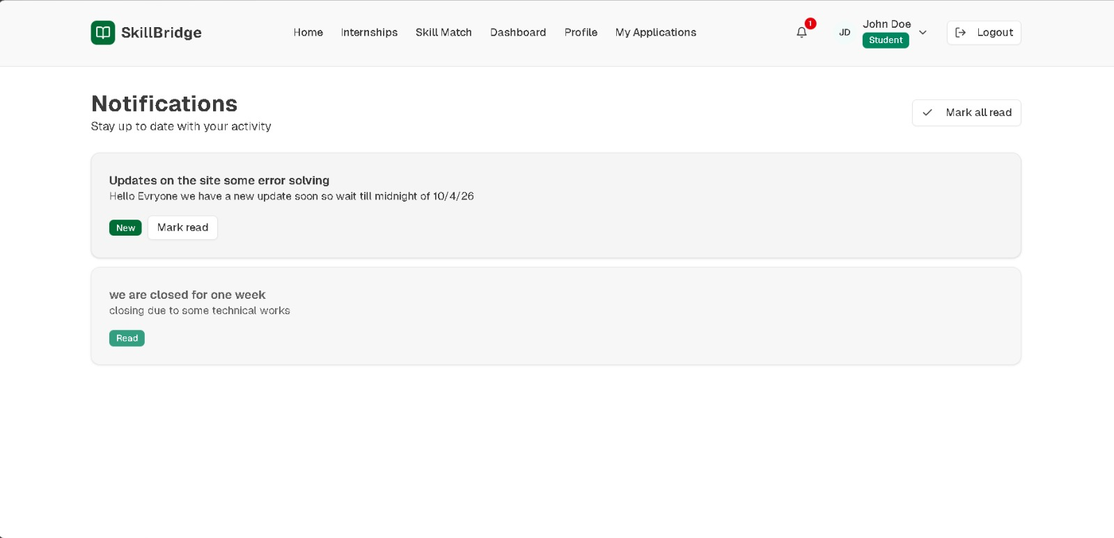

Figure 3.5.4 Student /user can see notification

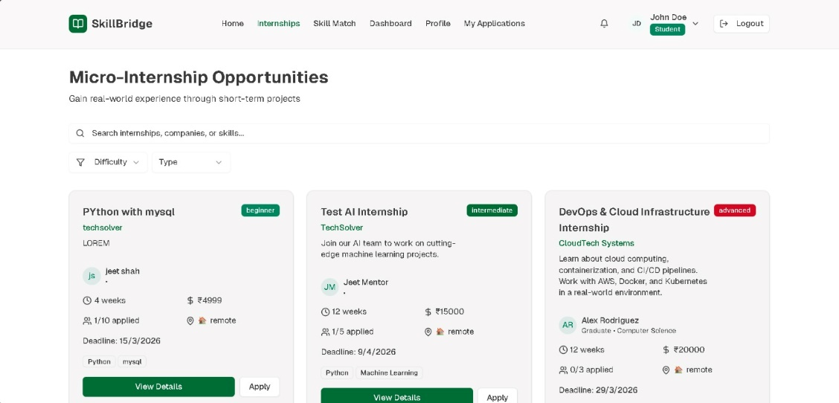

3.5.5.Student internship View

Data Flow Diagram (DFD)
A Data Flow Diagram (DFD) is a graphical representation of the flow of data through an information system. It models the processes, external entities, data stores, and the data flows that connect them, providing a clear visual understanding of how data moves through the system. For the SkillBridge portal, a Level 0 Context Diagram and a Level 1 DFD have been prepared to illustrate the system's data interactions at progressively greater levels of detail.

Level 0 DFD – Context Diagram
The Level 0 DFD, also known as the Context Diagram, represents the entire SkillBridge system as a single central process. It shows the three primary external entities that interact with the system: the Student, the Employer, and the Administrator. Students provide registration data, profile information, resume uploads, and application submissions to the system, and receive personalized job recommendations and status updates in return. Employers submit company profiles and job postings, and receive application data and candidate shortlists. Administrators provide management commands and receive system reports and usage statistics.
Registration, Profile, Job Postings, Resume, Applications Company Profile
SkillBridge System
Recommendations,
Process 0
Status Updates Smart Internship Portal
Applications, Shortlisted Candidates
Reports & Statistics
Management & Policy Commands

Admin

Employer

Student
Figure 3.6.1: Level 0 Context Diagram – SkillBridge System

Level 1 DFD
The Level 1 DFD expands the central SkillBridge process into its six major sub-processes: User Authentication and Registration, Profile and Resume Management, Job and Internship Posting, Search and Recommendation Engine,

Application Management, and Admin Control and Reporting. These processes interact with three data stores: the User Database, the Job/Internship Database, and the Application Database. Data flows between external entities, processes, and data stores are explicitly shown to illustrate how information is created, transformed, and consumed throughout the system.

Figure 3.6.2: Level 1 Data Flow Diagram – SkillBridge System

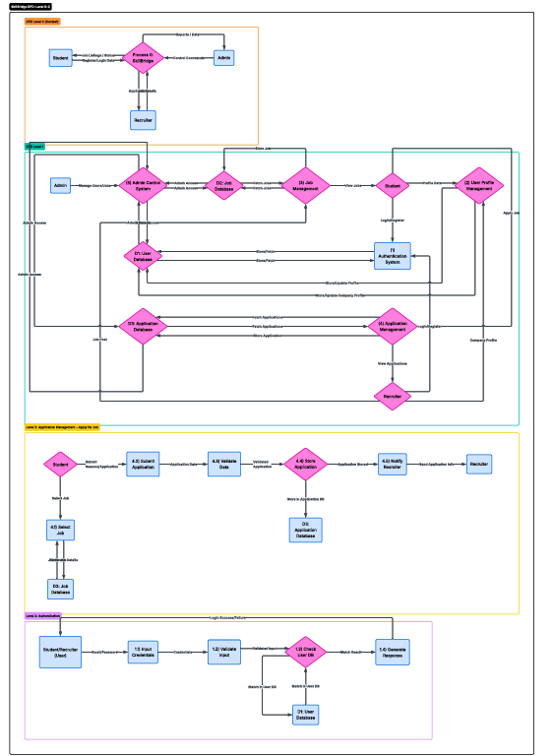

Chapter 4: Limitations and Future Enhancements

Limitations of the Current System

Limited Artificial Intelligence Features
The current implementation of the SkillBridge system provides only basic job and internship recommendations based on profile-to-keyword matching. The system does not yet incorporate advanced Artificial Intelligence or Machine Learning algorithms for intelligent skill-to-requirement matching, predictive analytics, or dynamic learning paths. As a result, the recommendation engine operates at a rudimentary level compared to mature platforms that leverage large-scale training data and complex recommendation models.

Absence of a Mobile Application
The current project has been developed exclusively as a web-based platform. There is no dedicated mobile application available for Android or iOS users, which limits the platform's accessibility for students who primarily use smartphones for browsing and communication. Mobile accessibility is particularly critical in the Indian academic context, where a large proportion of students rely on mobile internet for daily digital activities.

Manual Verification Processes
Employer registration approvals and job posting validations currently require manual review by the system administrator. This introduces a potential bottleneck as the platform scales, since the volume of incoming registrations and postings may exceed what an individual administrator can process in a timely manner. Automation of these verification processes would significantly improve the platform's efficiency.

Limited Communication Features
The communication capabilities between students and employers in the current version are limited to basic application status updates. The system does not support real-time chat, in-portal messaging threads, or video interview scheduling within the platform. These features are increasingly expected by users of modern recruitment platforms.

Internet Dependency
As a fully web-based application, SkillBridge requires a stable internet connection to function properly. There is no offline mode or local caching mechanism that

would allow students to browse previously loaded listings without an active internet connection, which represents a limitation in regions with unreliable connectivity.

Future Enhancements

Mobile Application Development
A high-priority future enhancement is the development of native Android and iOS applications for the SkillBridge platform. A mobile app would enable push notifications for real-time opportunity alerts, improved accessibility on smaller screens, and a more seamless experience for mobile-first users. This would significantly broaden the platform's reach across India's large mobile internet user base.

Automated Employer and Job Verification
An automated verification system for employer registrations and job postings would reduce the administrative burden on the system administrator and improve the platform's responsiveness. This could involve integrations with company databases, automated document verification using OCR, or machine learning classifiers trained to identify and flag potentially fraudulent or inappropriate listings.

Real-Time Communication Features
Introducing live chat, video calling, or a structured in-portal messaging system would enable direct, efficient, and trackable communication between students and recruiters. This would eliminate the need for external email exchanges and allow the entire recruitment interaction to occur within the platform, improving transparency and user engagement for both parties.

AI-Based Job Matching and Resume Builder
Future versions of the platform could integrate advanced AI and Machine Learning algorithms trained on large datasets of successful placements to generate highly personalized and accurate job recommendations. Additionally, a built-in Resume Builder tool would help students create professional resumes directly on the platform, while integrated online Skill Assessment tests would allow students to validate their skills and improve their employability scores visible to employers.

Analytics Dashboard for Institutions
A future enhancement targeted at educational institutions would involve an analytics dashboard accessible to college placement officers and faculty. This would allow institutions to monitor the placement progress of their students, identify skill gaps, and establish targeted partnerships with companies, enabling

more effective career counseling and curriculum planning aligned with industry demands.

Chapter 5: Timeline Chart

The timeline chart below provides a breakdown of the effort distribution across the four primary activity categories of the SkillBridge project: Planning, Design, Coding, and Reporting. The distribution is visualized as a proportional pie chart, and the table below describes the percentage contribution and rationale for each category. This analysis reflects the team's prioritization of technical implementation while ensuring adequate investment in planning, visual design, and documentation to produce a complete and well-rounded academic deliverable.

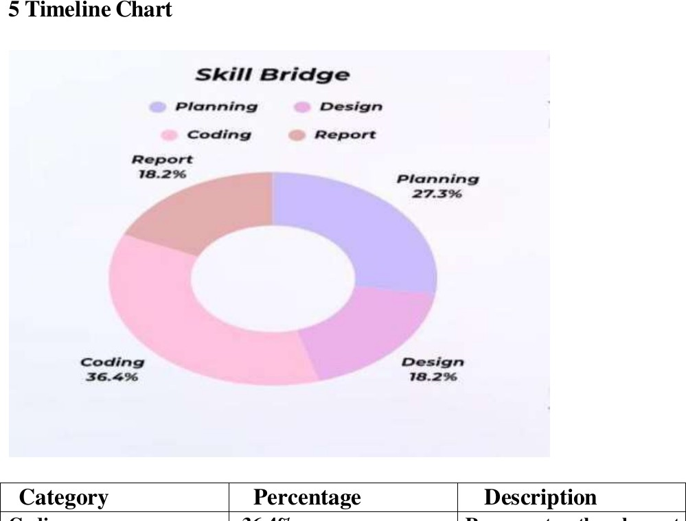
Figure 5.1: Project Timeline Distribution – SkillBridge

Category | Percentage | Description
Coding | 36.4% | Represents the largest share, indicating that technical implementation is the primary focus of the project. This includes frontend development, backend logic, database design, and integration work.
Planning | 27.3% | Reflects the importance of thorough preparation and strategic organization prior to execution, including requirement gathering, feasibility analysis, and project scope definition.
Design | 18.2% | Covers the creative and structural aspects of the project including UI/UX design, wireframing, and diagram creation, requiring moderate but focused effort.

Report | 18.2% | Reflects the documentation and analysis phase, ensuring clarity of results, proper academic formatting, and effective communication of the project's objectives and outcomes.
Table 5.1: Timeline Distribution Table

Chapter 6: Conclusion

The Smart Internship & Job Finder Portal for Students, developed under the brand name SkillBridge, represents an innovative and practically motivated solution to a well-recognised challenge faced by college students across India. The system successfully demonstrates how a centralized, intelligent, and user-friendly digital platform can bridge the significant gap that currently exists between students seeking career opportunities and employers searching for skilled and motivated candidates.
Through this project, the team has designed and documented a comprehensive web-based system that supports the complete hiring lifecycle — from student profile creation and resume uploading, to smart job recommendations, application tracking, and employer communication. The system's three-tier architecture, role-based access control, and intelligent recommendation engine collectively address the key deficiencies identified in the existing system analysis, including fragmented search processes, absence of personalization, communication gaps, and lack of centralized application management.
The feasibility analysis conducted across technical, economic, operational, time, and legal dimensions confirms that the project is viable and achievable within the scope and resources of an academic semester project. By leveraging modern open-source technologies — specifically HTML5, CSS3, JavaScript, Python with Django or Flask, and MySQL 8.0 — the system is designed to be cost-effective and scalable for future growth.
While the current version has certain limitations, including the absence of a mobile application, advanced AI-driven matching, and real-time communication features, the roadmap of future enhancements clearly outlines a path toward a fully mature, production-grade platform. The SkillBridge system has the potential to significantly improve placement outcomes for students, streamline the hiring process for employers, and provide educational institutions with meaningful data-driven insights into their students' career readiness.
In conclusion, this project has not only fulfilled the requirements of the Problem Based Learning – I course but has also delivered a meaningful, real-world applicable solution that reflects the team's collective skills in software engineering,

system design, and academic documentation. The SkillBridge platform stands as a testament to the practical value that well-executed academic projects can bring to the broader technology and education ecosystem.

References

The following references were consulted during the research, design, and development phases of the SkillBridge project.

- Internshala – India's No. 1 Internship and Training Platform. [Online]. Available: https://internshala.com
- LinkedIn Learning. Job and Internship Search Platform. [Online]. Available: https://www.linkedin.com
- Handshake – Career Network for College Students. [Online]. Available: https://joinhandshake.com
- W3Schools. HTML5, CSS3, JavaScript Documentation. [Online]. Available: https://www.w3schools.com
- Django Software Foundation. Django 4.x Documentation. [Online]. Available: https://docs.djangoproject.com
- Flask Documentation. Flask 3.x – A Micro Web Framework for Python. [Online].
Available: https://flask.palletsprojects.com
- MySQL AB. MySQL 8.0 Reference Manual. [Online]. Available: https://dev.mysql.com/doc/refman/8.0/en/
- Bootstrap. Bootstrap 5.3 Documentation. [Online]. Available: https://getbootstrap.com/docs/5.3
- GitHub, Inc. Git and GitHub Version Control Documentation. [Online]. Available: https://docs.github.com
- Amazon Web Services. AWS Cloud Hosting and Deployment Services. [Online].
Available: https://aws.amazon.com
- Firebase by Google. Firebase Platform Documentation. [Online]. Available: https://firebase.google.com/docs
- Vercel. Frontend Cloud Deployment Platform. [Online]. Available: https://vercel.com/docs
- Postman Inc. Postman API Testing Documentation. [Online]. Available: https://learning.postman.com
- Naukri.com. Job and Resume Search Platform in India. [Online]. Available: https://www.naukri.com
- Silver Oak University. Problem Based Learning Course Curriculum, Department of Computer Engineering, 2025–2026.

